**AWS Lambda S3 Tigger**

**Sign In into AWS Management Console**

* First Create a New Role in IAM that having access to AWS S3 and AWS CloudWatch

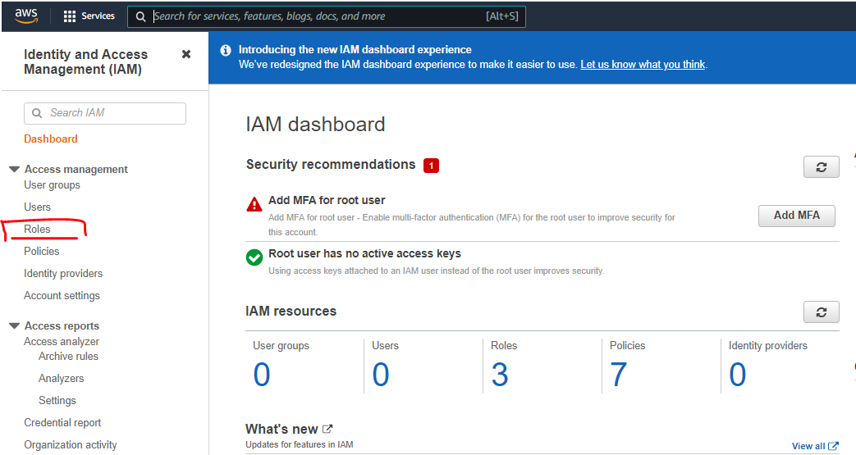

* Click on Create new role

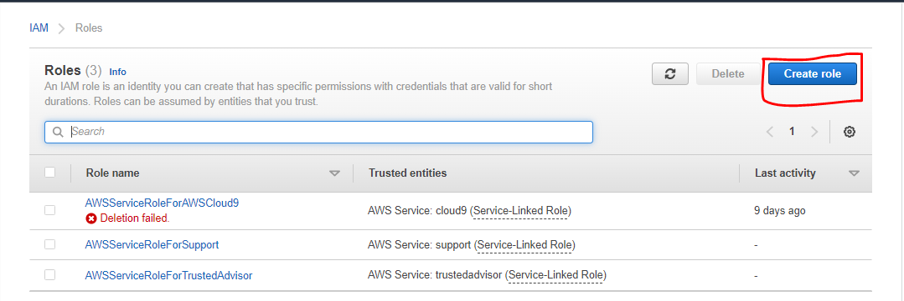

Select Use cases for lambda and trusted entity type AWS service because we are using this role for AWS lambda service.

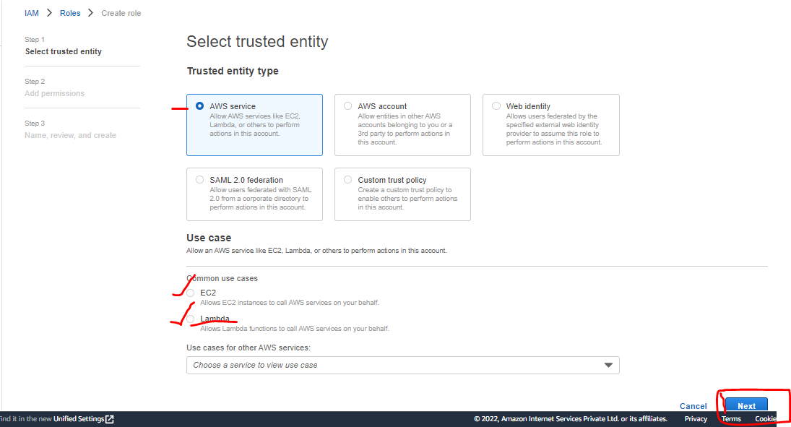

Add S3 permission policies to it

* Add S3 full access
* Add CloudWatch

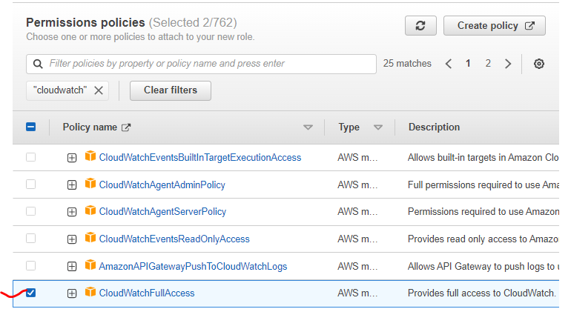

Click on Next

* Give the Name to the Role
* Review the details
* And click on create role

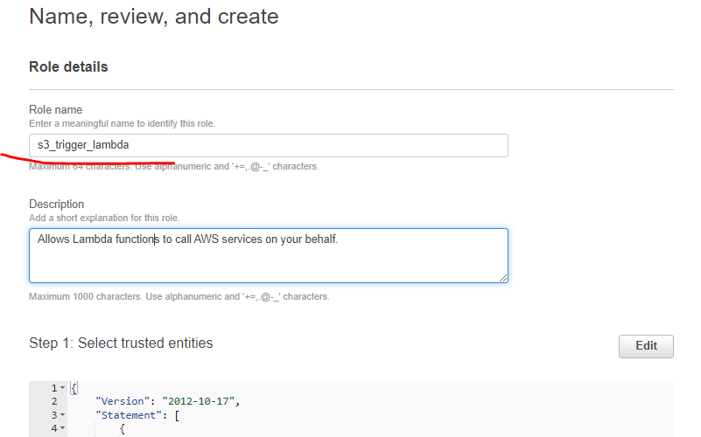

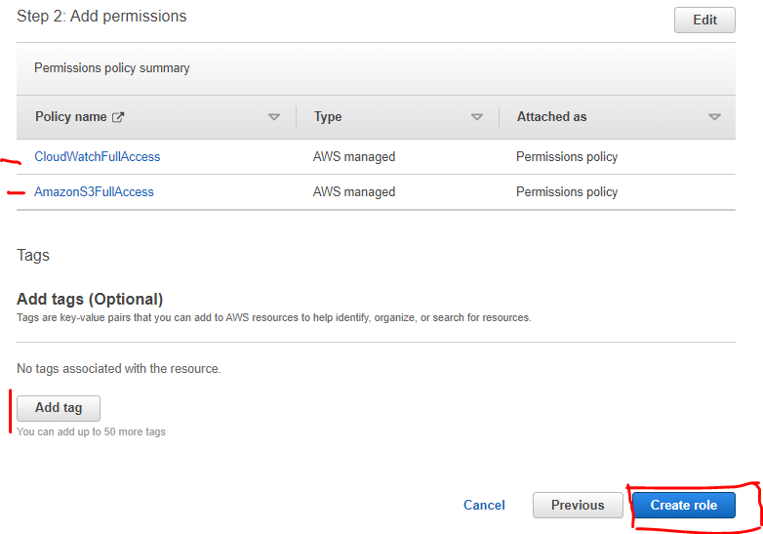

Your Role is Created

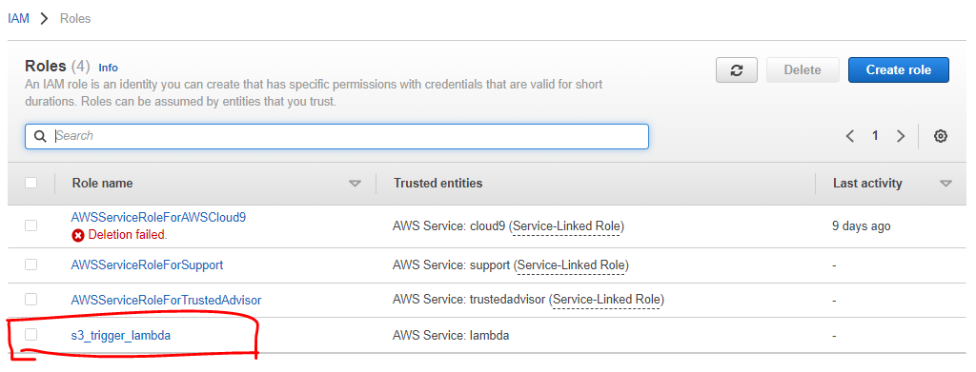

**Now we have to create S3 Bucket in AWS S3**

* Search S3 in search bar
* Create new S3 bucket

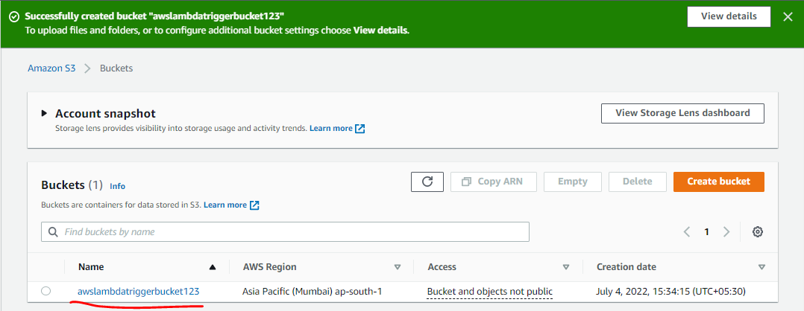

**Click on or Search Lambda Service.**

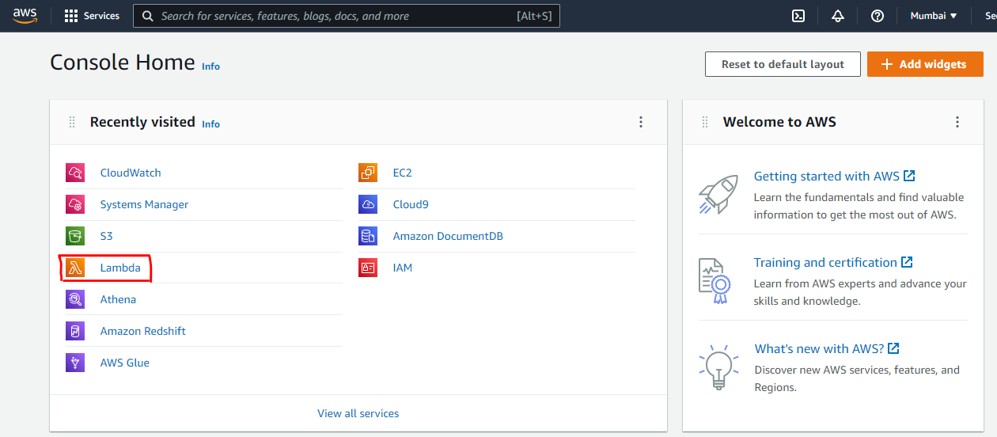

Click on Create function

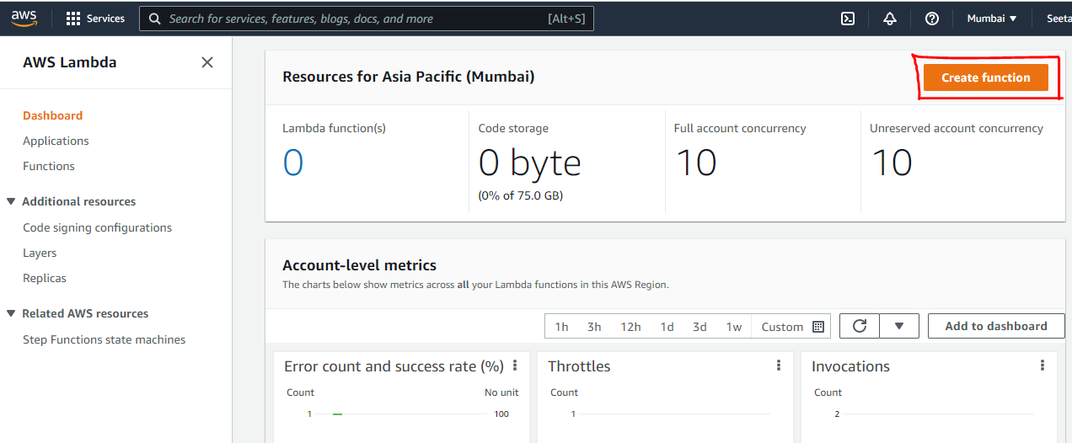

Name the Function

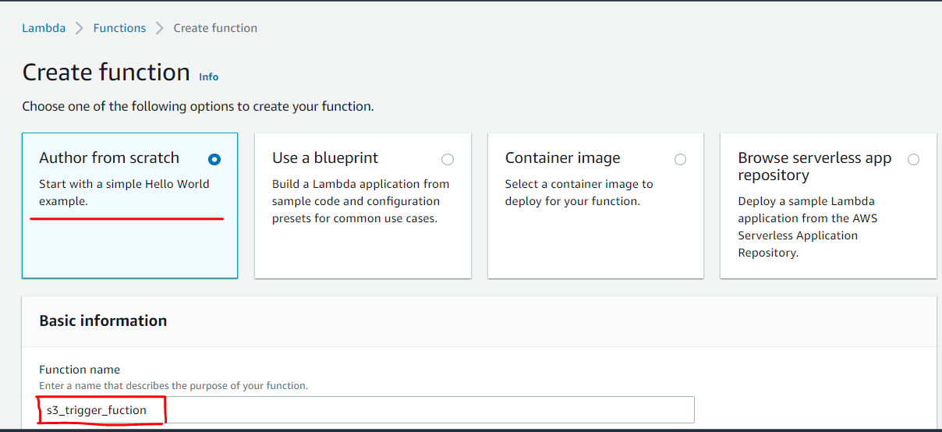

* Check the Runtime I have choose Python 3.9
* Architecture
* Use existing Role that we have created in Advance Setting
* Click on Create Funciton

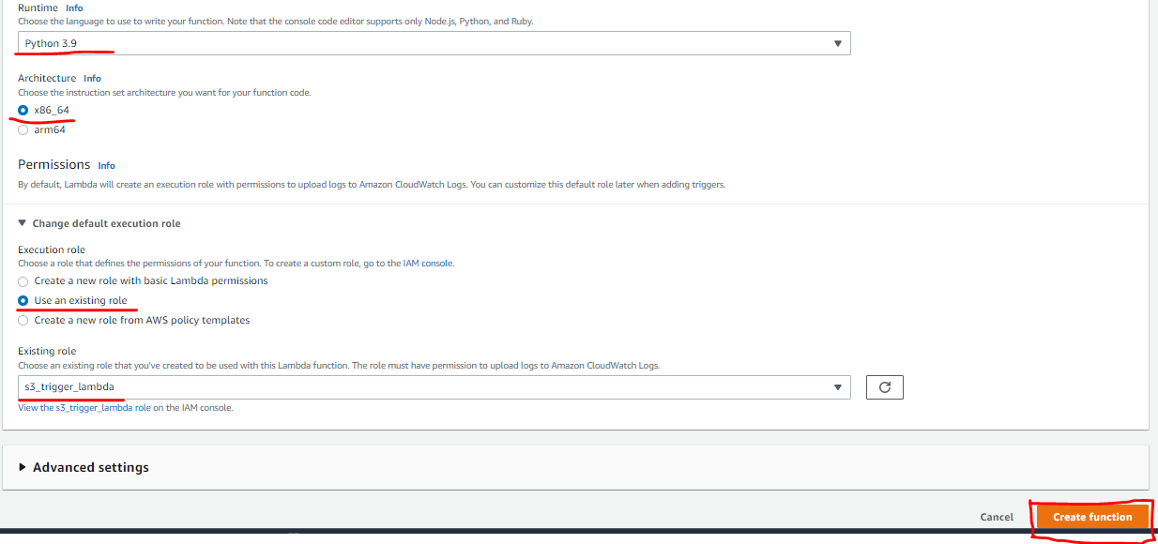

Click on Add trigger

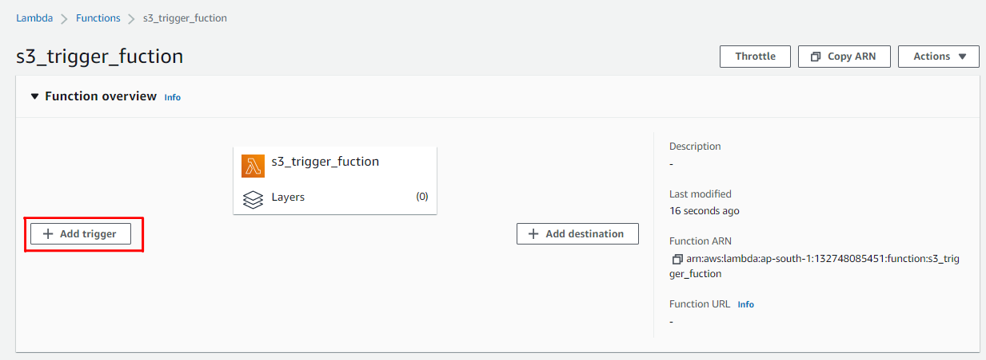

Trigger Configuration

* Select Data source or event happening service
* Select Bucket
* Select Event Type – PUT, POST, COPY, All, Etc.

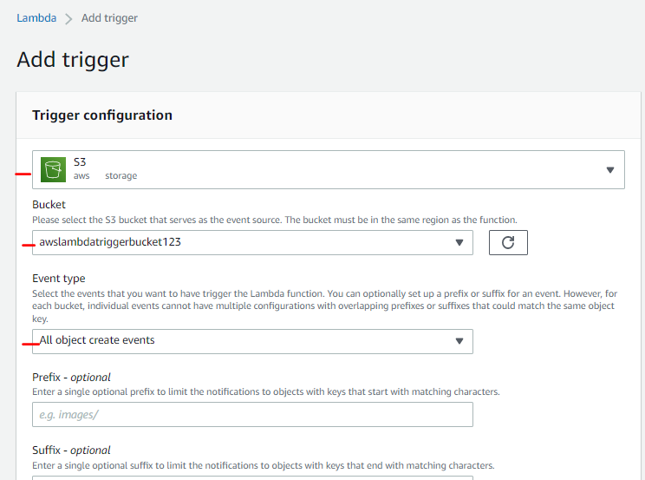

Check Acknowledge box and click on Add button

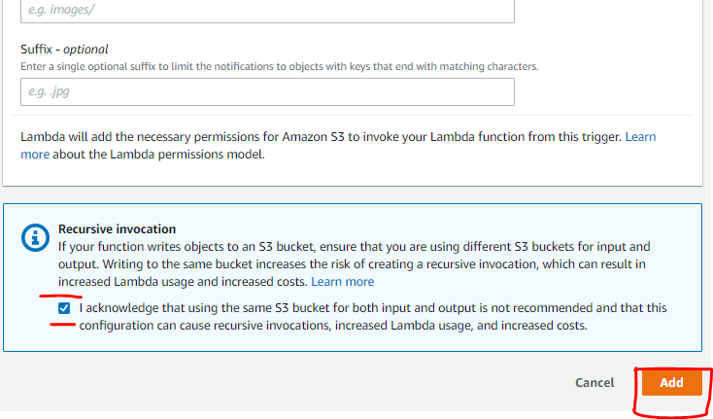

Now you can see your trigger service is added

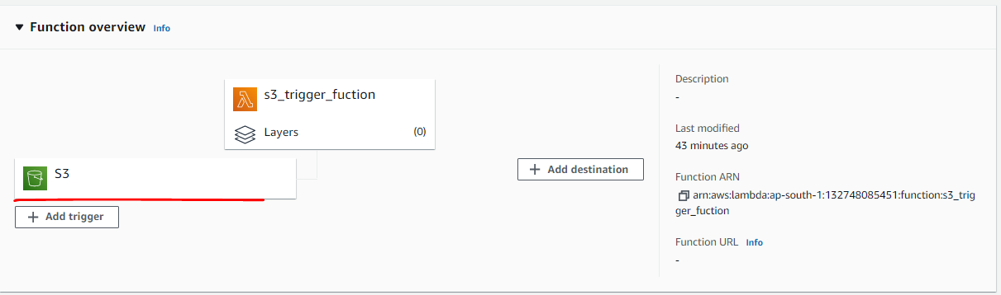

Like you can see in configuration tab triggers section

Click on Code tab

* Write a function on in lambda _function.py file as shown below
* That function will detect all incoming and outgoing file in S3 bucket
* Keep it record in CloudWatch Logs and return message that we have return
* Click on deploy button

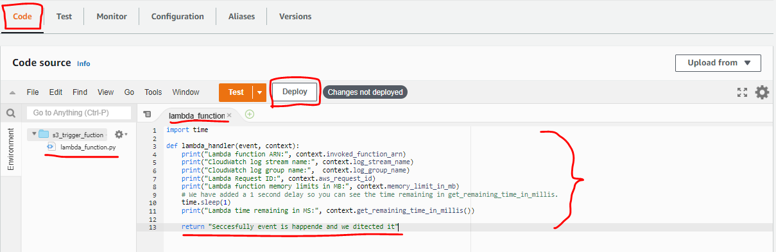

Now you can upload

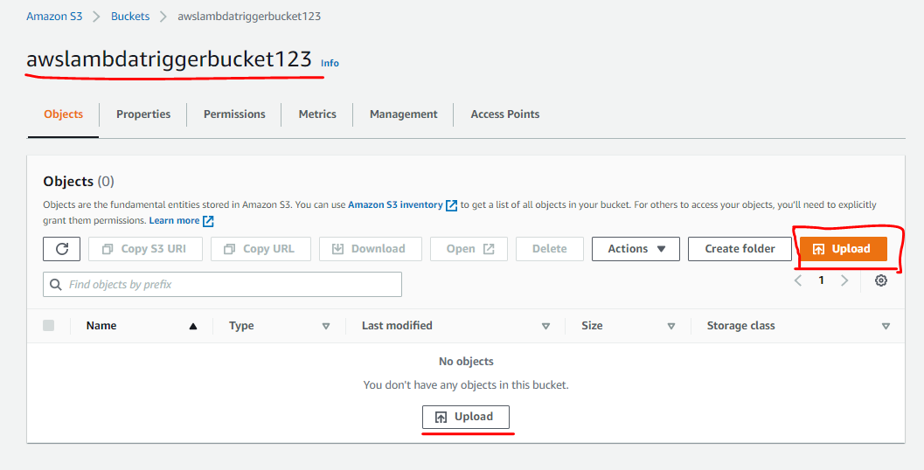

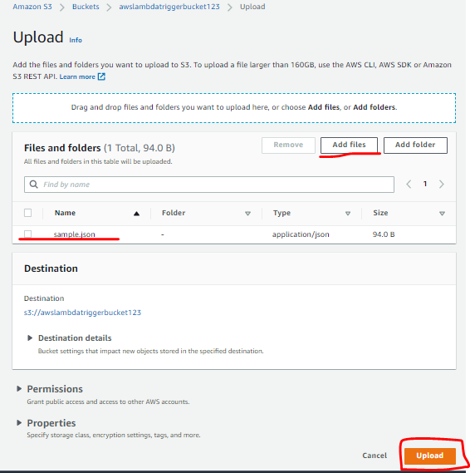

**Open CloudWatch and check logs event**

* Goto Logs
* And click logs recently created

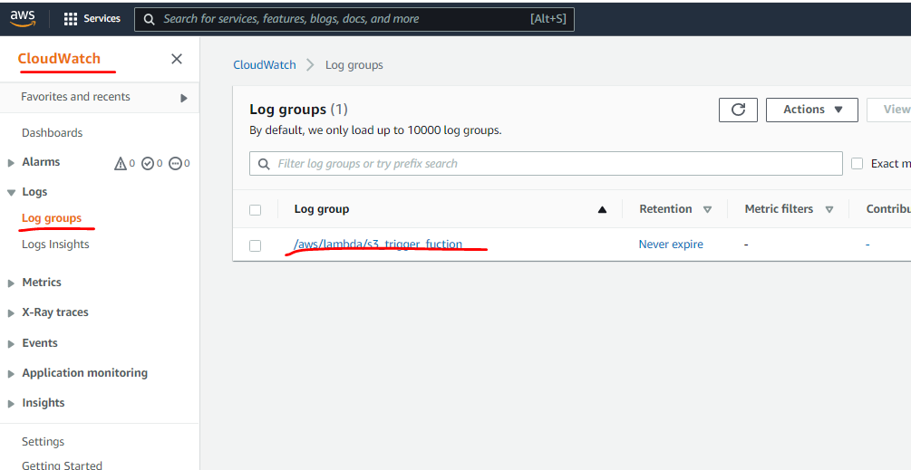

See the log events that is generated after uploading file in S3 bucket.

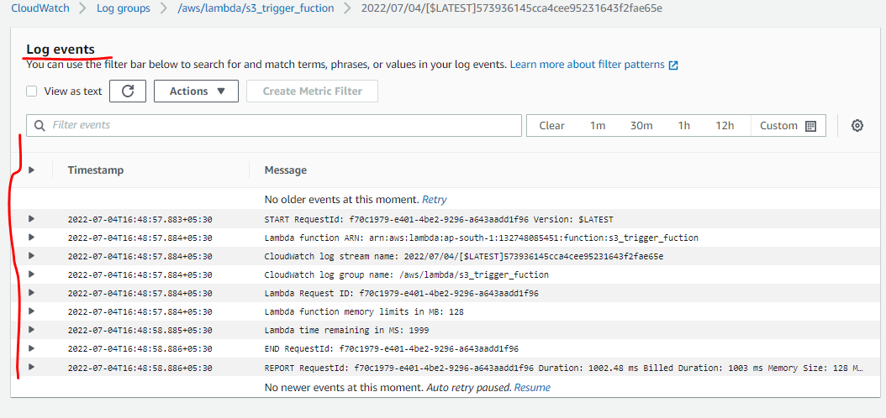

You can also see the event log after click on test button.

Click on Test and

* You can see the execution result
* Response is also visible in it
* You can see the function logs in snip
* That how you can create lambda function.

